5th March 2019

**YOKOHAMA Launches “G.T. SPECIAL CLASSIC”, a Revival Tyre for Historic Cars**

YOKOHAMA announced today that it will launch sales in Europe of the “G.T. SPECIAL CLASSIC” in a revival of YOKOHAMA’s heritage G.T. SPECIAL brand. The new tyre is based on YOKOHAMA’s “G.T. SPECIAL Y350”. It delivers a soft, comfortable ride without losing the feel of a historical car and features the same classical tread pattern and side design of its predecessor. The “G.T. SPECIAL CLASSIC” will be available from this summer in three sizes – 165/80R15 87H, 175/80R14 88S and 165/80R14 85S.   
  
The first YOKOHAMA brand to use radial tyres, the G.T. SPECIAL brand was launched in 1967 under the catchphrase “Taking the lead in the radial era”. It secured its position as a YOKOHAMA heritage brand by contributing to the motorization of Japanese society in the 1960s and 1970s. In addition to a classic appearance suitable for use on historic Japanese and European cars from the 1960s and 1970s, the revival model “G.T. SPECIAL CLASSIC” makes use of the latest tire technologies and comes in tire sizes that will enhance the drivability and safety of historic cars.   
  
YOKOHAMA has been marketing the “ADVAN HF Type D”, another tyre suitable for use with historic cars, in Japan since 2017. By continuing to supply tyres for historic cars, YOKOHAMA is joining car lovers around the world in sustaining the classic car culture.   
  
YOKOHAMA has established its hobby tyre strategy as one of core elements of the broader consumer tyre strategy included in the Company’s three-year medium-term management plan, Grand Design 2020 (GD2020), implemented from 2018. In line with its hobby tyre strategy, the Company is accelerating the development of new products and expanding the size line-up of existing products suitable for use with various types of hobby vehicles, from race cars to classic cars.

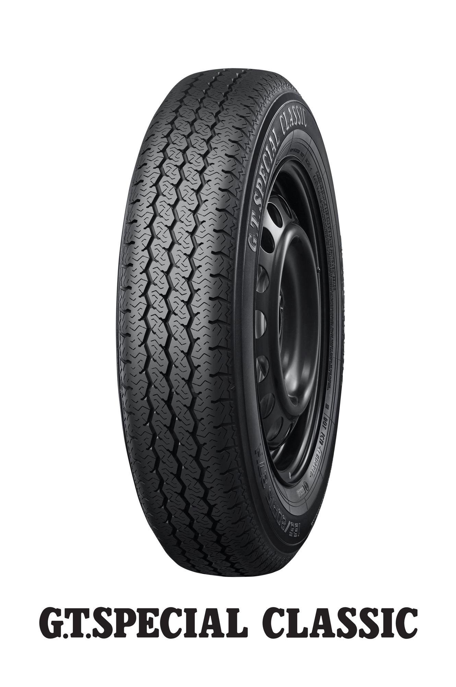

*G.T. SPECIAL CLASSIC*